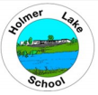
HOLMER LAKE PRIMARY SCHOOL
SEND Newsletter
December 2025
SEND Review Meetings

Parents evening took place on Tuesday 25^{h} December. At this meeting, your child’s first SEND review for this school year would have taken place. Your child’s class teacher will have discussed your child’s provision map, reviewing, and assessing (Review and Assess) your child’s progress from the beginning of the Autumn Term.
A copy of your child’s provision map for Autumn Term will be sent home.
If you have any concerns or would like to discuss your child’s needs further, please speak to your child’s class teacher.
At Holmer Lake Primary School, our children are at the centre of everything we do. We aim to identify the needs of all pupils as early as possible. This is part of our graduated approach, in which we Assess, Plan, Do, Review. This ongoing cycle ensures that effective provision is put in place and removes barriers to learning. We have a range of interventions taking place daily in our school to meet the needs of all our children. We believe in inclusivity for all and strive to make this a reality for all our pupils.

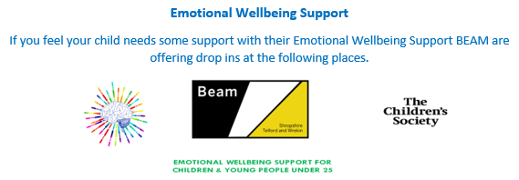
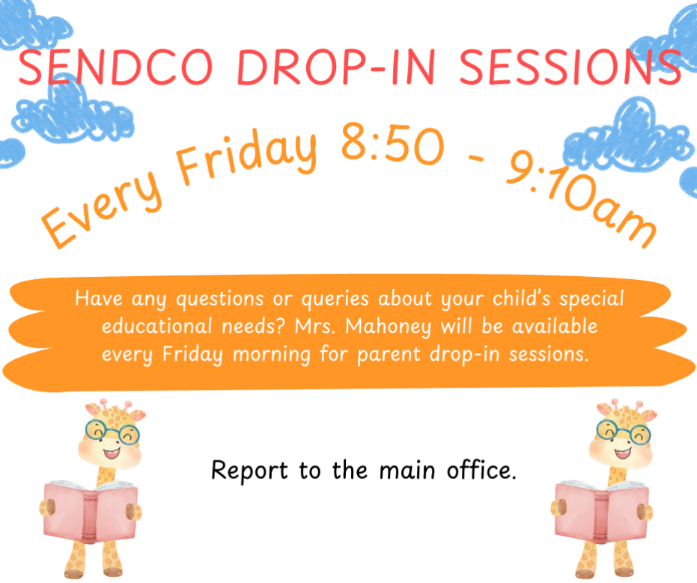



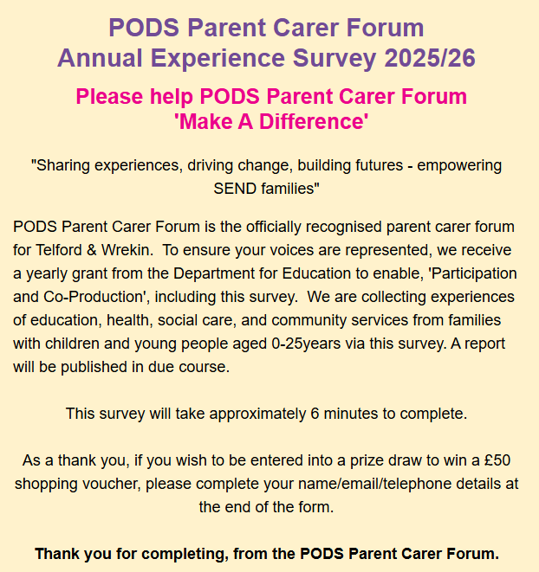

https://forms.office.com/pages/responsepage.aspx?id=qbj2J5Ku30CYXh_za8XoLq8LC0gsLW9CoRjKLxMiFaBUNkFDSlhDRE01Q0FDVzNBNVNXNEZSNkxPNy4u&route=shorturl
SEND Information
School’s SEND Offer:
http://www.holmerlakeprimary.org/key-information/send
Telford & Wrekin SEND Local Offer:
https://www.telfordsend.org.uk/site/index.php

