Reading Newsletter
Spring Term 2023
READING NEWS
Year 1 are busy preparing for the phonics screening check!
The Year 1 phonics screening check is not a formal test, but a way for teachers to ensure that children are making sufficient progress with their phonics skills to read words and that they are on track to become fluent readers who can enjoy reading for pleasure and for learning.
If your child is in Year 1, they will be checked on their phonics skills during the week commencing Monday 12th June. Year 2 children who did not pass the check last year will also be checked again. Your child will need to read real words as well as nonsense words (alien words). This is to check that they are able to break up words into the different sounds they have been taught and blend them correctly.
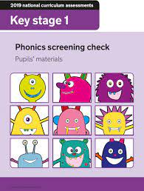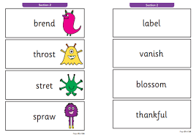

READING AT HOLMER LAKE
Remember to read with your child 3 times a week and write it in their diary. Children who read 3 or more times a week at home receive a prize out of their class prize box on a Friday.

RECCOMMENDED READING – poetry focus
Reception | Years 1 and 2 | Years 3 and 4 | Years 5 and 6
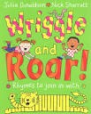 | 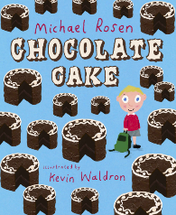 | 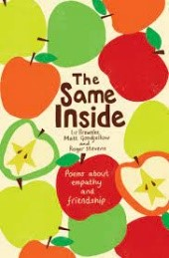 | 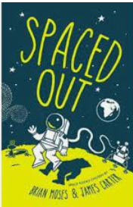
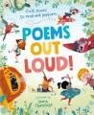 | 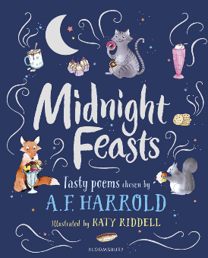 | 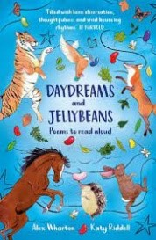 | 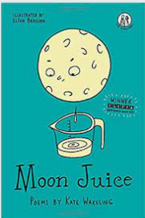
AUTHOR(S) OF THE AUTUMN TERM
RMW | 1P | 12M
Michael Rosen, Eileen Browne, Emily Gravett and Nick Butterworth | Steve Antony | Jill Tomlinson and Philip Reeve
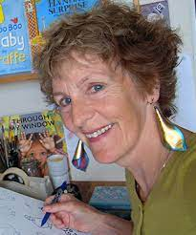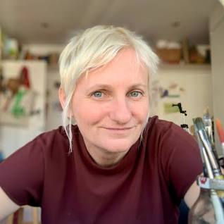 |  | 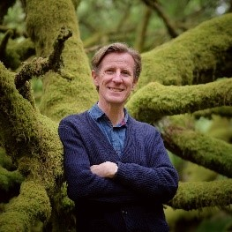
3N | 34W | 4L
Catherine Johnson | Cressida Cowell | Tony Bradman
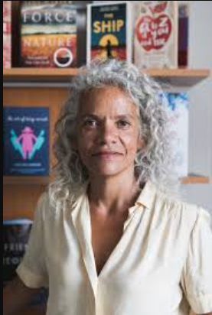 | 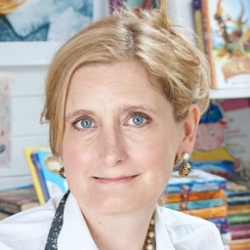 | 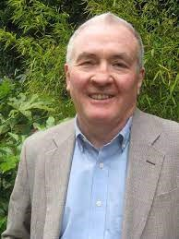
5J | 56G | 6M
E Nesbit | Berlie Doherty | Peter Bunzl
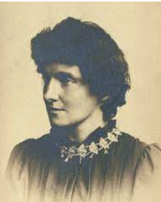 | 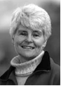

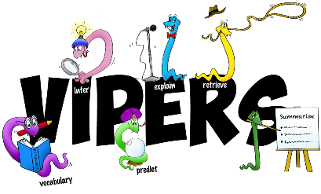
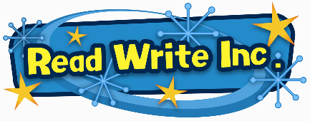
SPRING TERM READING TARGETS

RMW | I can choose books to read.  I am beginning to read words containing the sounds I have been taught.
1P | I can distinguish between a word, a letter, and a space.  I can comment on what is being said or done.  I can sometimes identify when reading does not make sense and attempt to self-correct.
12M | I can read most words quickly and accurately, without sounding and blending, when I have read them before.  I can make links between the book I am reading and other books I have read.  I can comment on obvious characteristics and actions of characters in stories.
3N | I can participate in discussions about which texts to read and can justify reasons why.  I am beginning to read in-between the lines using clues from the text and pictures to discuss thoughts, feelings, and actions.  I understand how a character could be seen in different ways, depending on how the author chooses to portray them.
34W | I can read all common exception words (Year 3/4 spelling list).  I can predict what might happen from details stated or implied (using an image/chapter title/ single sentence).  I can identify main ideas drawn from more than one paragraph.
4L
5J | I can apply my growing knowledge of root words, prefixes, and suffixes to understand the meaning of new words that I meet.  I can make inferences from the text and deduce the moods and feelings of the characters  I can make comparisons within and across books (e.g. Comparing characters or books by different authors)
56G
6M | I can explain and justify inference with evidence from the text.  I apply my growing knowledge of root words, prefixes and suffixes to understand the meaning of new words that I meet.  I use quotations and text references to support ideas and arguments.

