Area of Learning | Autumn 1 |  |  |  | Autumn 2 | Spring 1 | Spring 2 |  | Summer 1 |  |  |  | Summer 2
THEME  Possible interests/lines of enquiry | Me and My World  Ourselves and our families  People who help us  Superheroes  My environment |  |  |  |  | Adventures above and below the clouds  Journeys  Space  Countries around the world  Types of transport |  |  | Roots, shoots and muddy boots  Growing Plants – Healthy Eating  Minibeasts  Traditional Tales
Golden Threads – Planned Links | Leadership – People who help us and role models in stories  Civilisation – Different jobs and why they are important, lives of different people, cultures, and beliefs  Following, leading and belonging  Special times, places and celebrations |  |  |  |  | Place (Countries around the world/where we live)  Human Environments (Travel)  Leadership – Castles, stories about kings and queens  Civilisation – Kingdoms  Conflict – Getting on and falling out  Following, leading and belonging  Special times, places and celebrations |  |  | The physical world  Interdependence (Farming)  Conflict – Getting on and falling out  Seasonality – Growing plants  Healthy Eating – Healthy diets linked to stories including Oliver’s Vegetable’s
Key Texts | Super Duper Me!  Supertato  A Superhero like You  Charlies Superhero Underpants  Busy People Series  Wild Woods  Gruffalo  Red Riding Hood  Stickman |  |  |  |  | Journey  Whatever Next!  On the Way Home  Naughty Bus  Handa’s Surprise  Train Ride  The Hundred Decker Bus  Little People, Big Dreams (Mary Anning/Ernest Shackleton/Amelia Earhart) |  |  | Farmer Duck  Superworm  What the Ladybird Heard  The Very Hungry Caterpillar  Jack and the Beanstalk  Oliver’s Vegetables  Ten Seeds
Memorable Experiences/Curriculum Enhancements | Woodland Walks  Superhero discoveries  Visitors including dental hygienist, police |  |  |  |  | Walk around local area  Bus ride |  |  | Chicks  Caterpillars  Shropshire Hills Discovery Centre
Communication and  Language  (Listening and attention,  understanding and speaking) | Understand how to listen carefully and why listening is important.  Engage in story times.  Listen attentively and respond to what they hear with relevant questions, comments and actions when being read to and during whole class discussions and small group interactions. |  |  |  | Ask questions to find out more and to check they understand what has been said to them.  Develop social phrases  Engage in story times.  Make comments about what they have heard and ask questions to clarify their understanding.  Hold conversation when engaged in back-and-forth exchanges with their teacher and peers. | Articulate their ideas and thoughts in well-formed sentences.  Connect one idea or action to another using a range of connectives.  Engage in non-fiction books.  Listen to and talk about selected nonfiction to develop a deep familiarity with new knowledge and vocabulary.  Participate in small group, class and one-to-one discussions, offering their own ideas, using recently introduced vocabulary.  Express their ideas and feelings about their experiences using full sentences, including use of past, present and future tenses and making use of conjunctions, with modelling and support from their teacher. | Describe events in some detail  Use talk to help work out problems and organise thinking and activities explain how things work and why they might happen.  Offer explanations for why things might happen, making use of recently introduced vocabulary from stories, nonfiction, rhymes and poems when appropriate. |  | Listen to and talk about stories to build familiarity and understanding.  Engage in non-fiction books. Listen to and talk about selected non-fiction to develop a deep familiarity with new knowledge and vocabulary.  Offer explanations for why things might happen, making use of recently introduced vocabulary from stories, non-fiction, rhymes and poems when appropriate.  Express their ideas and feelings about their experiences using full sentences, including use of past, present, and future tenses and making use of conjunctions, with modelling and support from their teacher. vocabulary in different contexts |  |  |  | Retell the story once they have developed a deep familiarity with the text; some as exact repetition and some in their own words.  Use new vocabulary in different contexts.  Express their ideas and feelings about their experiences using full sentences, including use of past, present and future tenses and making use of conjunctions, with modelling and support from their teacher.
Learn new vocabulary
Use new vocabulary through the day
Listen carefully to rhymes and songs, paying attention to how they sound.
Learn rhymes, poems, and songs
Use new vocabulary in new contexts.

Personal, Social and  Emotional  Development  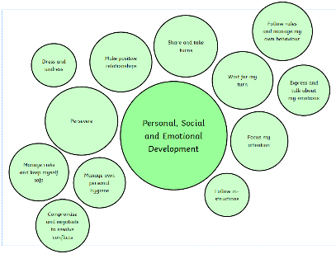 | See themselves as a valuable individual.  Build constructive and respectful relationships.  Express their feelings and consider the feelings of others, regulate behaviour accordingly.  Work and play cooperatively and take turns with others  Give focused attention to what the teacher says  Manage own basic hygiene and personal needs  Know and talk about the different factors that support their overall health and wellbeing: regular physical activity, healthy eating, toothbrushing, sensible amounts of ‘screen time’, having a good sleep routine, being a safe pedestrian. |  |  |  |  | Show resilience and perseverance in the face of challenge.  Identify and moderate their own feelings socially and emotionally.  Be confident to try new activities  Manage own basic hygiene and personal needs.  Self-Regulation  Managing Self  Building Relationships |  | Show understanding of their own feelings and those of others, and begin to regulate their behaviour accordingly  Set and work towards simple goals  Confident to try new activities,  Explain the reasons for rules  Manage own basic hygiene and personal needs  Self-Regulation  Managing Self  Building Relationships | Think about the perspectives of others.  Manage their own needs.  Show understanding of their own feelings and those of others, and begin to regulate their behaviour accordingly  Set and work towards simple goals  Confident to try new activities, Explain the reasons for rules  Manage own basic hygiene and personal needs  Know and talk about the different factors that support their overall health and wellbeing: regular physical activity, healthy eating, toothbrushing, sensible amounts of ‘screen time’, having a good sleep routine, being a safe pedestrian. |  |  |  | Show sensitivity to their own and to others’ needs  Be confident to try new activities and show independence, resilience and  perseverance in thefaces of challenge  Give focused attention to what the teacher says, responding appropriately even when engaged in activity, and show an ability to follow instructions involving several ideas or actions  Self-Regulation  Managing Self  Building Relationships
 |  | Self-Regulation
 |  | Managing Self
 | Building Relationships
 |  |  |  |  |  |  |  |  |  | Self-Regulation
 |  |  |  |  |  |  |  |  |  | Managing Self
 |  |  |  |  |  |  |  |  |  | Building Relationships
 | NB. These statements have been split for extra focus, but all will apply on an ongoing basis throughout the reception year.

Physical Development  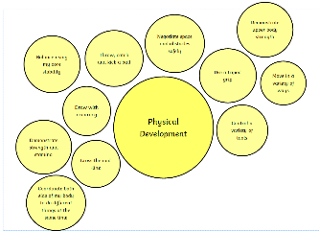 | Further develop the skills they need to manage the school day successfully: lining up and queuing, mealtimes, personal hygiene  Develop fine motor skills- holding pencil correctly, using scissors etc |  |  |  | Revise and refine the fundamental movement skills they have already acquired: rolling, crawling, walking, jumping, running, hopping, skipping, climbing.  Develop fine motor skills- holding pencil correctly, using scissors etc | Further develop and refine a range of ball skills including throwing, catching, kicking, passing, batting, and aiming.  Develop confidence, competence, precision, and accuracy when engaging in activities that involve a ball.  Develop fine motor skills |  | Combine different movements with ease and fluency  Develop the foundations of a handwriting style which is fast, accurate and efficient. | Confidently and safely use a range of large and small apparatus indoors and outside and in a group.  Fine Motor Skills
Develop the overall body strength, co-ordination, balance, and agility needed to engage successfully with future physical education sessions and other physical disciplines including dance, gymnastics, sport, and swimming.
Develop their small motor skills so that they can use a range of tools competently, safely, and confidently. Suggested tools: pencils for drawing and writing, paintbrushes, scissors, knives, forks, and spoon. Use their core muscle strength to achieve a good posture when sitting at a table or sitting on the floor.
Literacy  Comprehension, word reading, Writing  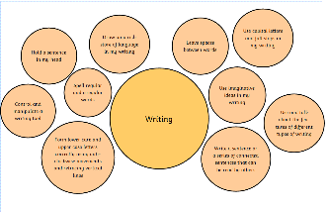  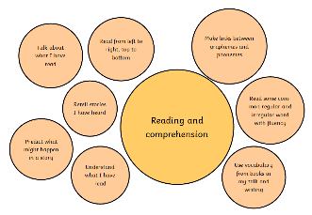  Phonics  RWI | Read individual letters by saying the sounds for them.  Demonstrate understanding of what has been read to them by retelling stories and narratives using their own words and recently introduced vocabulary.  Anticipate (where appropriate) key events in stories.  Use and understand recently introduced vocabulary during discussions about stories, non-fiction, rhymes and poems and during role play.  Say a sound for each letter in the alphabet  Write recognisable letters, most of which are correctly formed. |  |  |  | Blend sounds into words, so that they can read short words made up of known letter-sound correspondences.  Demonstrate understanding of what has been read to them by retelling stories and narratives using their own words and recently introduced vocabulary.  Anticipate (where appropriate) key events in stories.  Use and understand recently introduced vocabulary during discussions about stories, non-fiction, rhymes and poems and during role play.  Say a sound for each letter in the alphabet  Read words consistent with their phonic knowledge by sound-blending.  Write recognisable letters, most of which are correctly formed.  Writes own name.  Represent some initial sounds correctly. | Read some letter groups that each represent one sound and say sounds for them.  Read a few common exception words matched to the school’s phonic programme.  Demonstrate understanding of what has been read to them by retelling stories and narratives using their own words and recently introduced vocabulary.  Anticipate (where appropriate) key events in stories.  Use and understand recently introduced vocabulary during discussions about stories, non-fiction, rhymes and poems and during role play.  Say a sound for each letter in the alphabet and at least 10 digraphs.  Read words consistent with their phonic knowledge by sound-blending.  Read aloud simple sentences and books that are consistent with their phonic knowledge, including some common exception words.  Write recognisable letters, most of which are correctly formed.  Spell words by identifying sounds in them and representing the sounds with a letter or letters. | Read simple phrases and sentences made up of words with known letter–sound correspondences and, where necessary, a few exception words.  Re-read these books to build up their confidence in word reading, their fluency and their understanding and enjoyment.  Demonstrate understanding of what has been read to them by retelling stories and narratives using their own words and recently introduced vocabulary.  Anticipate (where appropriate) key events in stories.  Use and understand recently introduced vocabulary during discussions about stories, non-fiction, rhymes and poems and during role play.  Say a sound for each letter in the alphabet and at least 10 digraphs.  Read words consistent with their phonic knowledge by sound-blending.  Read aloud simple sentences and books that are consistent with their phonic knowledge, including some common exception words.  Write recognisable letters, most of which are correctly formed using anti-clockwise movements  Spell words by identifying sounds in them and representing the sounds with a letter or letters. | Demonstrate understanding of what has been read to them by retelling stories and narratives using their own words and recently introduced vocabulary.  Anticipate (where appropriate) key events in stories.  Use and understand recently introduced vocabulary during discussions about stories, nonfiction, rhymes and poems and during role play.  Read words consistent with their phonic knowledge by sound blending.  Read aloud simple sentences and books that are consistent with their phonic knowledge, including some common exception words.  Write simple phrases and sentences that can be read by others.  Form lower-case and capital letters correctly.  Spell words by identifying the sounds and then writing the sound with letter/s. | Write  Demonstrate understanding of what has been read to them by retelling stories and narratives using their own words and recently introduced vocabulary.  Anticipate (where appropriate) key events in stories.  Use and understand recently introduced vocabulary during discussions about stories, non-fiction, rhymes and poems and during role play.  Read words consistent with their phonic knowledge by sound-blending.  Read aloud simple sentences and books that are consistent with their phonic knowledge, including some common exception words.  short sentences with words with known letter-sound correspondences using a capital letter and full stop.  Re-read what they have written to check that it makes sense.  Use phonic knowledge to spell regular and irregular words and some common irregular words.
 | Set 1 Sounds, begin to blend |  |  |  | Set 1 sounds and blending | Photocopy Ditties | Red Ditties | Green Storybooks | Green/Purple Story Books

Mathematics  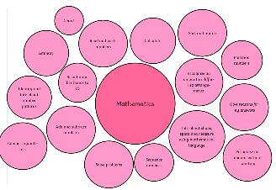 | Getting to know you  Just like me!  Match and Sort  Compare Amounts  Compare size, mass and capacity  Exploring pattern | Its me 1,2 3!  Light and Dark  Representing 1, 2 and 3  Comparing 1, 2 and 3  Composition of 1,2 and 3  Representing numbers to 5  One more and one less  Circles and Triangles  Positional Language  Shapes with 4  Time |  |  |  |  | Alive in 5!  Growing 6, 7, 8  Introducing zero  Comparing numbers to 5  Composition of 4 and 5  6, 7 and 8  Making Pairs  Combining 2 groups  Compare Mass  Compare Capacity  Length and Height  Time |  | Building 9 and 10  Consolidation  9 and 10  Comparing numbers to 10  Bonds to 10  3D Shape  Patterns | To 20 and beyond  First, then, now  Building numbers beyond 10  Counting patterns beyond 10  Adding More  Taking Away  Spatial Reasoning  Match, rotate and manipulate  Compose and Decompose | On the Move  Find the Pattern  Deepening Understanding Patterns and Relationships  Spatial Reasoning  Mapping
 | Early Comparison and pattern Counting and Cardinality Operations and Calculations Deep conceptual knowledge and understanding of numbers to 10
Understanding the World  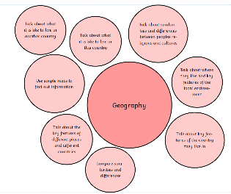  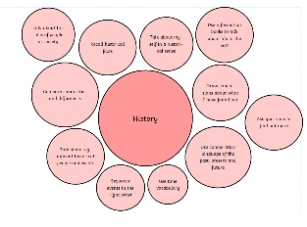  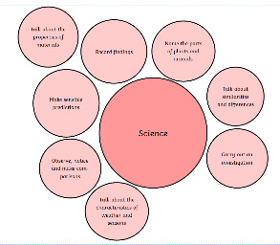 | Knows about some of the things that make them unique and can talk about some of the similarities and differences in relation to friends or family.  Name and describe people who are familiar to them.  Talk about members of their immediate family and community.  Learn about the different jobs people do and why they are important.  Know some similarities and differences between in the past and now.  Talks about past and present events in their own lives and in the lives of family members.  Knows that information can be retrieved from digital devices on the internet.  The Natural World  People, Culture and Communities  Past and Present | Recognise that people have different beliefs and celebrate special times in different ways.  Explore the natural world around them. making observations and drawing pictures of animals and plants.  Looks closely at similarities, differences, patterns and change in nature.  Completes a simple program on electronic devices. |  |  |  |  | Recognise some environments that are different to the one in which they live.  Recognise some similarities and differences between life in this country and life in other countries.  Similarities and differences between the natural world around them and contrasting environments, drawing on their experiences and what has been read in class  Understand the past through settings, characters and events encountered in books read in class and storytelling.  Can create content such as a video recording, stories and draw a picture on screen.  Comment on images of familiar situations in the past, including looking at transport change.  The Natural World  People, Culture and Communities  Past and Present |  | Understand that some places are special to members of their community.  Describe immediate environments.  Similarities and difference between different religious and cultural communities  Explain similarities and differences between life in this country and life in other countries through shared stories, including Africa and Australia.  Draw information from a simple map.  The Natural World  People, Culture and Communities  Past and Present | Explore the natural world around them  .  Draw information from a simple map.  Similarities and differences between the natural world around them and contrasting environments  Makes observations of animals and plants and explains why some things occur and talks about changes.  The Natural World  People, Culture and Communities  Past and Present | Comment on images of familiar situations in the past.  Name the parts of plants and animals.  Compare and contrast characters from stories, including figures from the past.  Can use the internet with adult supervision to find and retrieve information of interest to them.  The Natural World  People, Culture and Communities  Past and Present
 |  |  | The Natural World
 |  |  | People, Culture and Communities
 |  | Past and Present
Understand the effect of changing seasons on the natural world around them.
Describe what they see, hear, and feel whilst outside.
Talks about why things happen and how things work including magnets, ice melting, waterproof materials, pushes and pulls.

RE | Myself – Who am I? | Celebrating Festivals – Christmas, Diwali |  |  |  |  |  | Celebrating Festivals – Holi, Chinese New Year, Easter |  | Special Times – Welcoming a Baby/Weddings
Expressive Arts and  Design  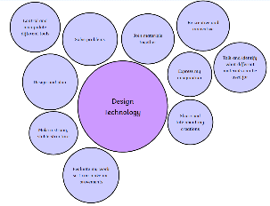  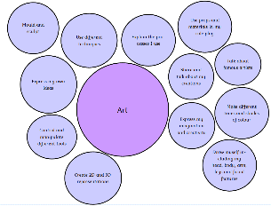 | Develop storylines in their pretend play.  Creating with Materials  Being imaginative | Sing in a group or on their own, increasingly matching the pitch and following the melody.  Creating with Materials  Being imaginative |  |  |  |  | Creating with Materials  Being imaginative  Return to and build on their previous learning, refining ideas and developing their ability to represent them  Begin to build a collection of songs and dancse. |  | Creating with Materials  Being imaginative  Create collaboratively sharing ideas, resources, and skills. | Listen attentively, move to and talk about music, expressing their feelings and responses.  Uses their increasing knowledge of understanding of tools and materials to explore their interests and enquires and develop their thinking.  Creating with Materials  Being imaginative | Watch and talk about dance and performance art, expressing their feelings and responses
 |  |  |  |  |  |  |  |  |  |  |  | Creating with Materials
 |  |  |  |  |  |  |  |  |  |  |  | Being imaginative
Explore, use, and refine a variety of artistic effects to express their ideas and feelings
Explore and engage in music making and dance, performing solo or in groups.

